Barnard College
Neuroscience & Behavior Department
Updated July 2022

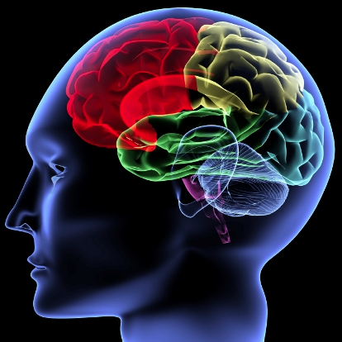

Department Chair: Prof. Peter Balsam, pbalsam@barnard.edu
Department Representative: Prof. Kara Pham, kpham@barnard.edu
Department Administrator: Dr. Michele Miozzo, mmiozzo@barnard.edu

This major provides a strong background in the biological underpinnings of behavior and cognition, and is intended for students who plan to pursue a research career in neuroscience or a related discipline. Students electing this major are exposed to courses in Neuroscience, as well as Biology, Chemistry, Psychology, Physics, and Computer Science.

All majors engage in two semesters of independent research during the senior year while enrolled in the Senior Research (Thesis) Seminar. In the junior year, majors must begin developing a plan for the senior research project. There is a meeting for junior majors during the Fall and Spring semesters to begin this process.

There are no minors in NSB.

Neuroscience & Behavior Faculty

Core Faculty

Peter Balsam (pbalsam@barnard.edu) is exploring how animals learn about time and use it to guide behavior. He also studies the neural mechanisms that underlie this capacity.

Elizabeth Bauer (ebauer@barnard.edu) is investigating the neurophysiological underpinnings of emotions and memory.

BJ Casey (bcasey@barnard.edu) is exploring neurobiological changes during the extended period of adolescence related to emotion and cognition and their implication for justice policy.

Maria de la Paz Fernandez (mfernand@barnard.edu) researches the neural mechanisms underlying aggressive behavior and territoriality, and the relation between the circadian clock and social behaviors.

John Glendinning (jglendin@barnard.edu) is examining how input from different chemosensory systems (taste, tactile, odor and viscerosensory) modulates feeding responses of animals.

Gabrielle Gutierrez (ggutierr@barnard.edu) creates computational models to understand how the properties of individual neurons affect, for example, the retina’s ability to transmit high-fidelity visual information, or a motor circuit to produce coordinated rhythmic movement, or a neural circuit to adapt to changing inputs.

Russell Romeo (rromeo@barnard.edu) focuses on how gonadal sex hormones and adrenal stress hormones influence the pubertal maturation of the nervous system and behavior.

Rae Silver (rsilver@barnard.edu) is examining hormonal control of reproductive behavior and circadian rhythms in behavior.

Alex White (alwhite@barnard.edu) is investigating visual perception, attention, reading, and cognitive development.

Affiliated/Adjunct Faculty/Term Professors

William Fifer, wpfl@columbia.edu Luca Iemi, liemi@barnard.edu
Ken Light, klight@barnard.edu E’mett McCaskill, emccaski@barnard.edu
Janet Metcalfe, jm348@columbia.edu John Morrison, jmorrison@barnard.edu
Alison Pischedda, apischedda@barnard.edu Robert Remez, remez@columbia.edu
Ari Shechter, aschechte@barnard.edu Carl Schoonover, cschoono@barnard.edu
Jonathan Snow, jsnow@barnard.edu Kathleen Taylor, ktaylor@barnard.edu
Abigail Zadina, az2361@clumbia.edu

NSB curriculum

The new NSB curriculum requires a total of 13 courses: 4 introductory courses, 7 additional courses, and a year-long research seminar counting as 2 courses. Elective courses can be chosen within one track: cognitive/behavioral, computational, or molecular. NSB majors are also required to complete a senior thesis. Courses planned for the new curriculum are presented on the next page.

Independent Study

Every student can carry out a neuroscience project under the supervision of an investigator in a laboratory at Barnard and Columbia or ‘off-site.’ This is a great opportunity for experiencing neuroscience research first-hand and familiarizing with the investigation conducted in a specific lab. This course requires approval from an NSB Barnard faculty and can be worth 1 to 4 credits (each credit is equivalent to approximately three hours of work per week). All students are required to submit a final research report that describes the objectives and results of the projects. The report can take the form best suited to the nature of the project. For more information about the Independent Study, visit the section Curriculum & Courses of the NSB webpage (https://neuroscience.barnard.edu/neuroscience-curriculum-and-courses).

A note for Pre-meds

A few courses in the new NSB Curriculum are also Pre-med requirements. These courses are listed in the table below.

From Required Courses
Intro to Cell & Molecular Biology (Lect+Lab; BIOL BC1502 & 1503)
Statistics & Research Methods (BIOL BC2286) or Intro to Statistics (STAT UN1101) or Statistics (PSYC BC1101)
From Approved Elective Courses
(Can count towards major requirement if not used to fulfill the NSB Introductory Course requirement)
Intro to Organismal/Evol Biology (Lect+Lab; BIOL BC1500 & 1501)
General Chemistry (Lect & Lab; CHEM BC2001 & 2012)
Organic Chemistry (Lect+Lab)
Biochemistry (Lect+Lab)
Mechanics (Lect & Lab) (PHYS BC2001 & 2009)
Electricity & Magnetism (Lect & Lab; PHYS BC2002 & 2019)

